**PRACTICAL-01**

Aim: Introduction to CISCO Packet Tracer software.

1.Use different types of devices like pc, switches, cables, pc with wireless card.

2.Create basic topologies and assign IP address, subnet mask, DNS, gateway IP address.

3.Test connectivity with ping command.

1. Create basic topologies and assign IP address, subnet mask, DNS, gateway IP address.

Network Topologies:

Network topology refers to the manner in which the links and nodes of a network are arranged to relate to each other.

Assigning IP address to the devices:

An IP address is a unique address that identifies a device on the Internet or a Local network.

IP stands for ‘Internet Protocol’, which is the set of rules governing the format of data sent via the internet and local network. A Subnet is a logical subdivision of an IP network.

DNS is the hierarchical and decentralized naming system used to identify computers, services and other resources reachable through the internet.



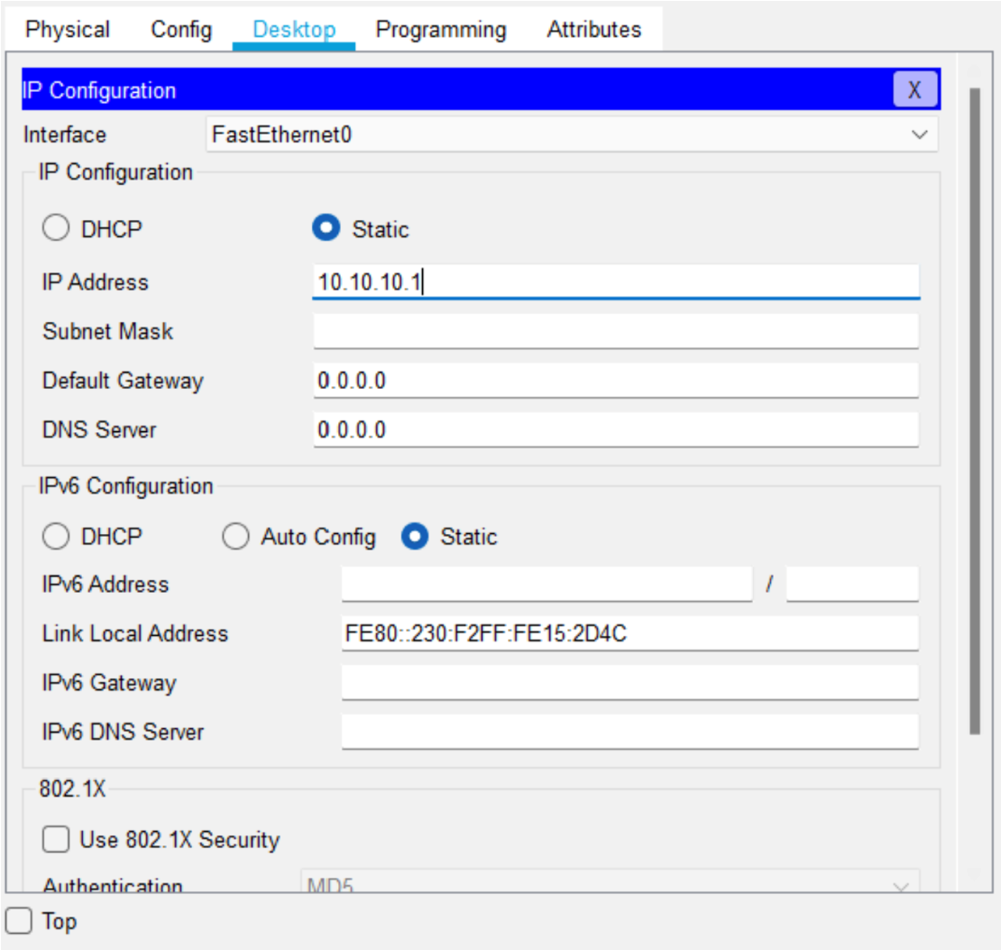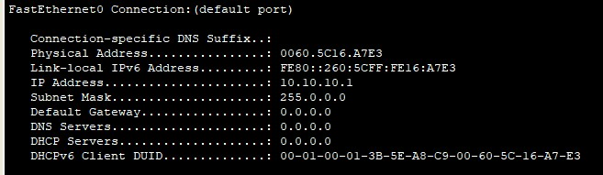

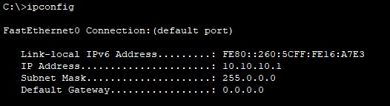

As you assign IP address to any devices double click on it then go to desktop then go to IP configuration.



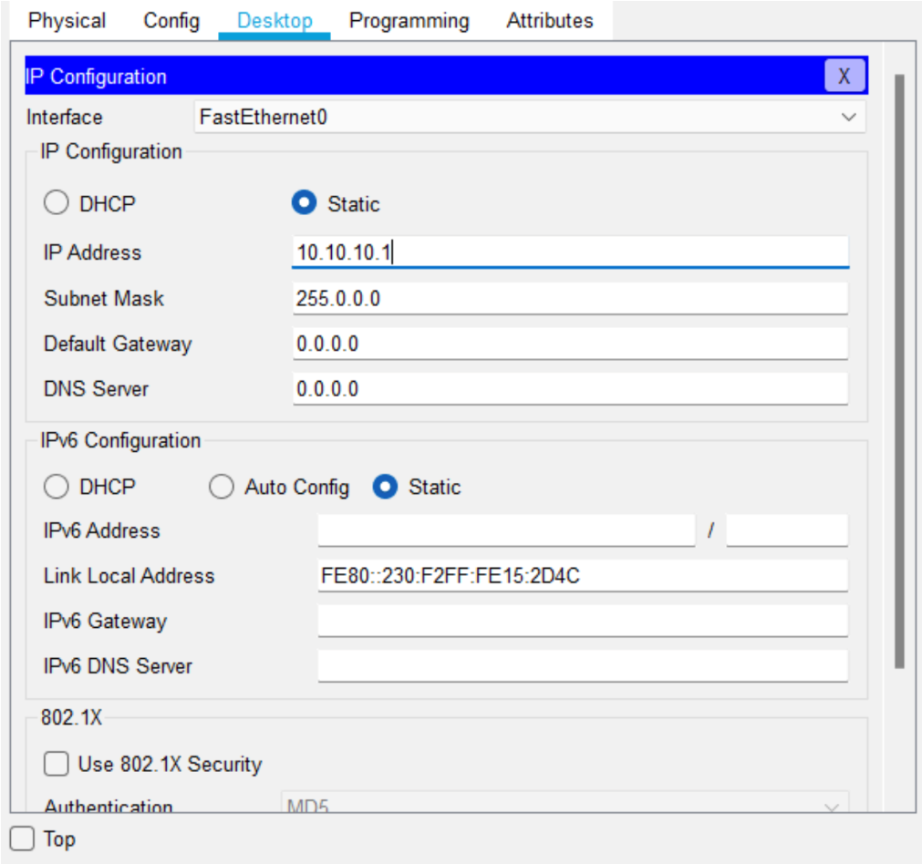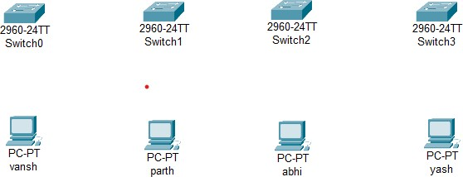

Setting IP address of pc1(vansh):

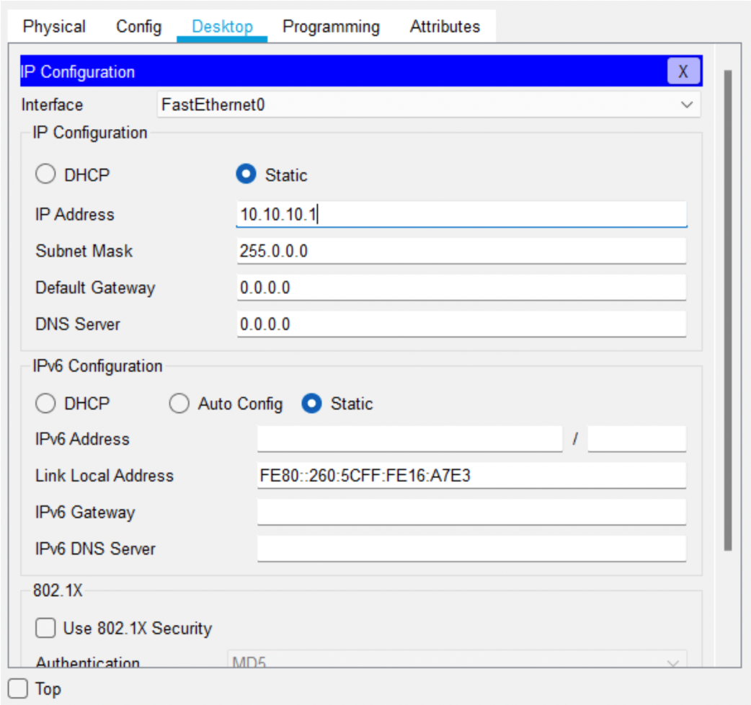

Setting IP address of pc2(parth):

 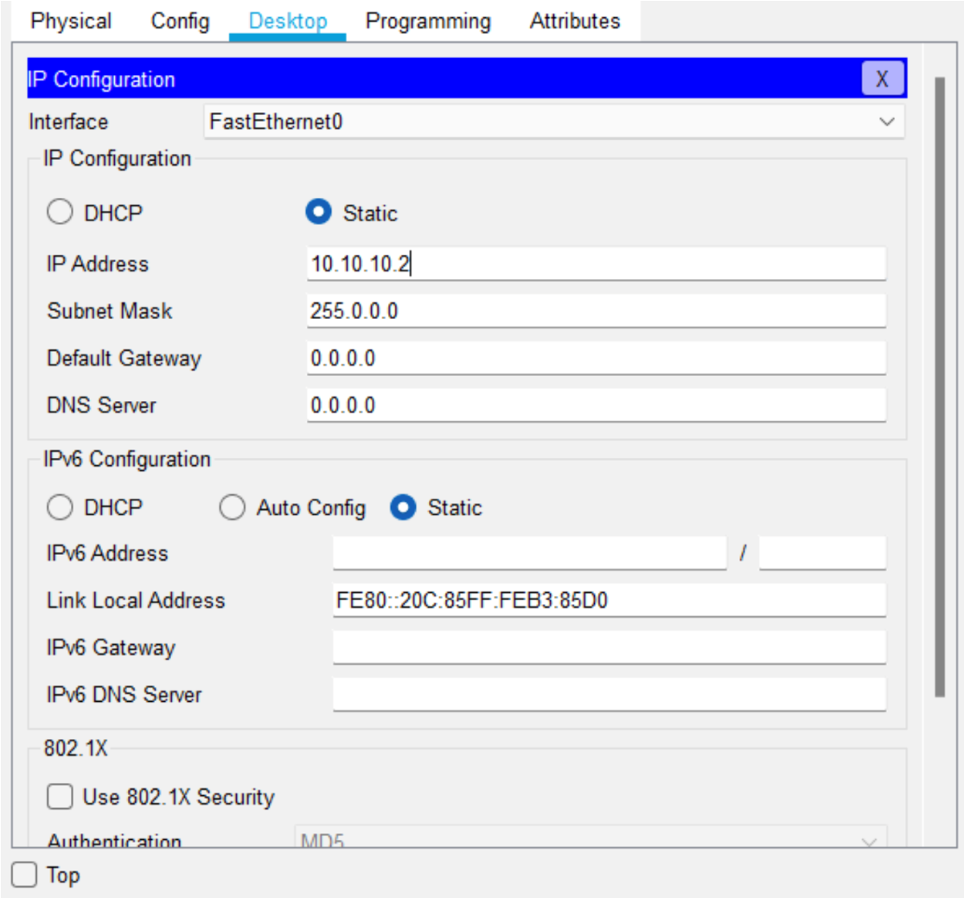

Setting IP address of pc3(abhi): 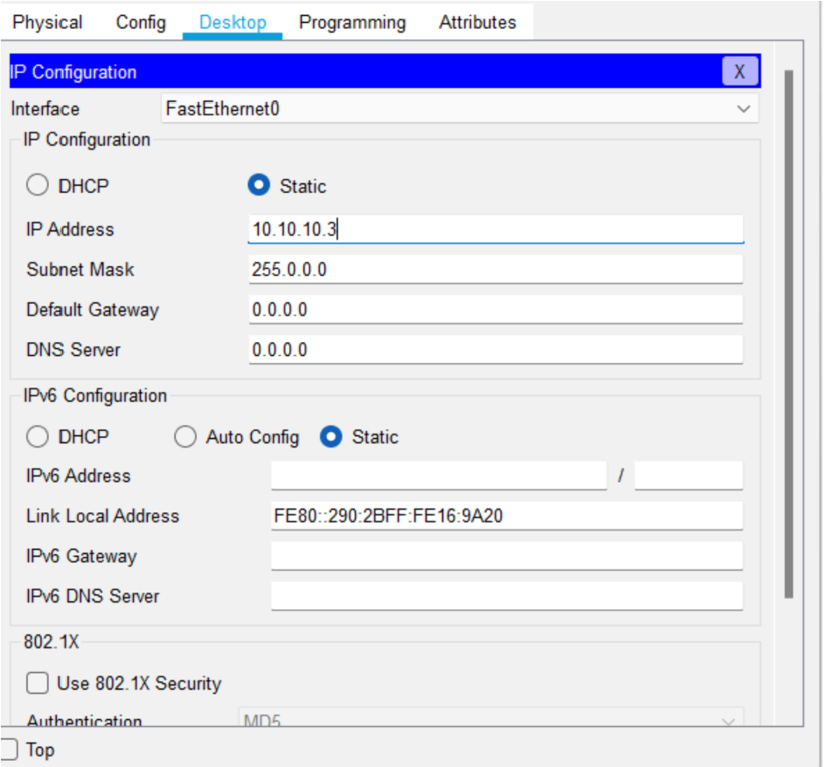

 Setting IP address of pc4(yash): 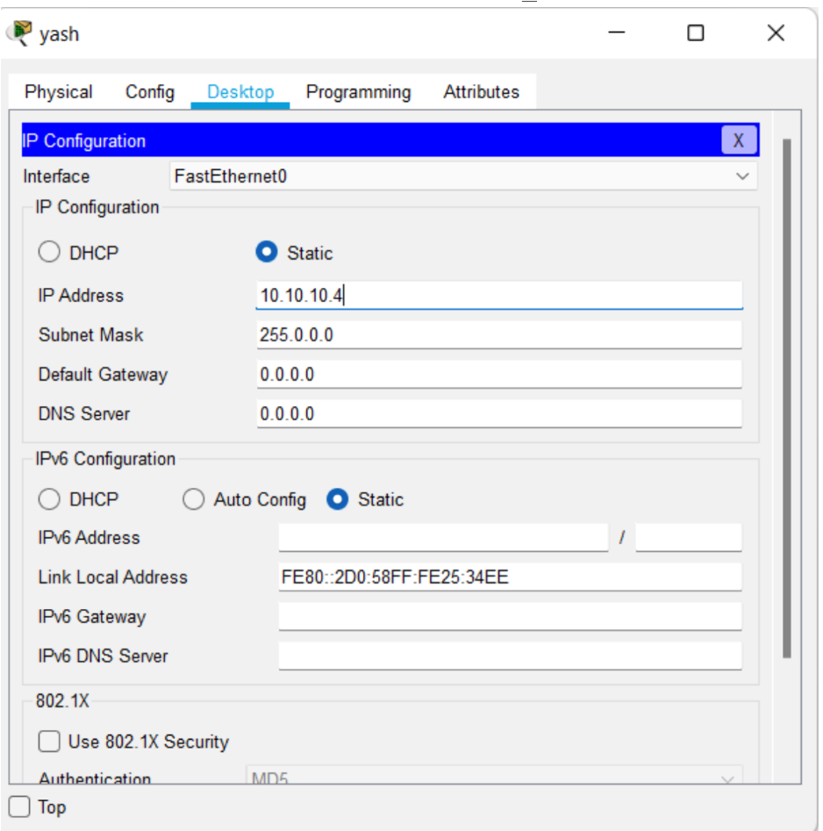

**Bus Topology:**

Bus topology also known as line topology, is a type of network topology in which all devices in the network are connected by one central cable or coaxial cable.

Advantages:-

—It works very efficient well when there is a small network. cost effective.

Disadvantages:-

—If the main cable fails or gets damaged then the whole network will fail. —If more devices are connected then due to data traffic, it will become slower. Step1:-select same number of end devices and switches.

Step2:-connecting all end devices with drop line using straight through cable.

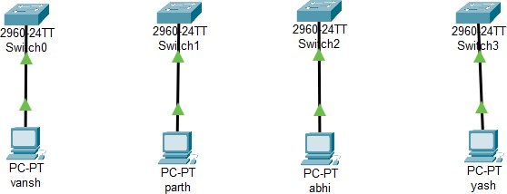

Step3:-connecting all switches copper cross over.

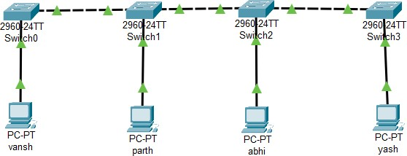



# Star Topology:-

Star topology is a network topology in which each network components is physically connected to a central node such as a router, hub, switch.

Advantages:-

—If one cable or device fail then all others will continue to work. —No data collision.

Disadvantage:-

—If the hub or switch fails then whole network will stop working.

—It is expensive to install as this type of network uses the most cables.

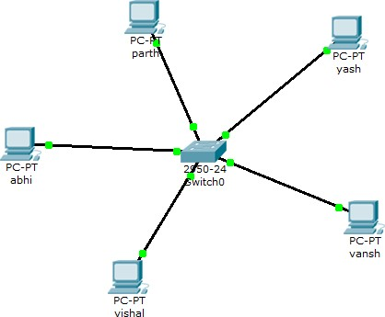



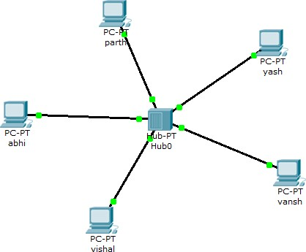

# Ring Topology:-

A ring topology is a network configuration where device connection creates a circular data path. Each device have two neighbor devices.

Advantages:-

—All data flow in one direction, reducing the chance of packet collisions.

—Data can transfer between workstations at high speed.

Disadvantages:-

—If the workstation shuts down, it affects whole network or if a node goes down entire network goes down.

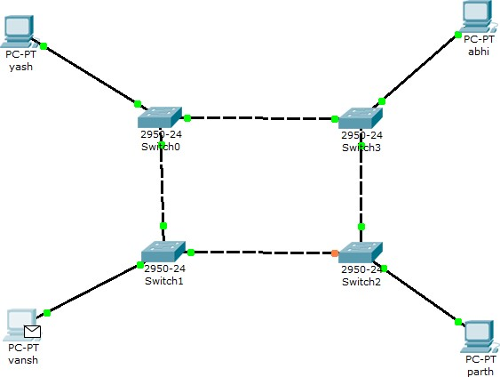



—It is slower in performance as compared to bus topology.

# Mesh Topology:-

In mesh topology each node or devices are connected with each other.

Advantages:-

—Messages can be received more quickly.

—Multiple connections mean that no node should be isolated. Because of it messages can be sent via multiple routes.

Disadvantages:-

—Installation is extremely complex. It is very costly because of so many connections.

—power requirement is higher as all nodes will need to remain active all the time and share the load.

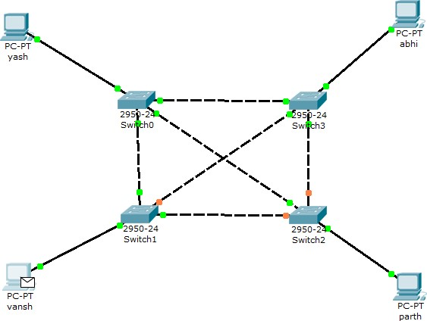

# Hybrid topology:-

A hybrid topology is a type of network topology that uses two or more differing network topologies.

Advantages:-

—It is extremely flexible. —It is very reliable.

Disadvantages:- —It is expensive.

—There is change in hardware in order to connect topology with different topology.

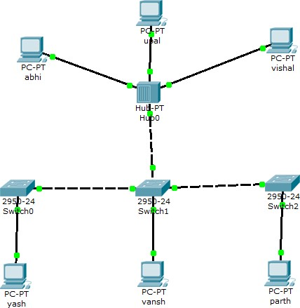

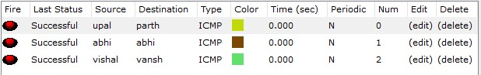

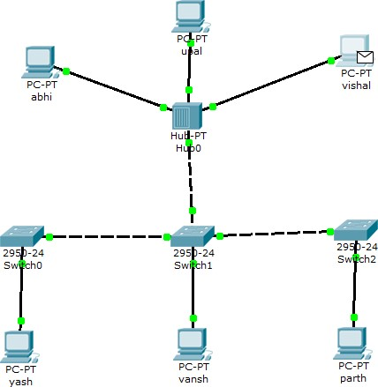

**3. Test connectivity with ping command**.

➔ Syntax= Ping (target)

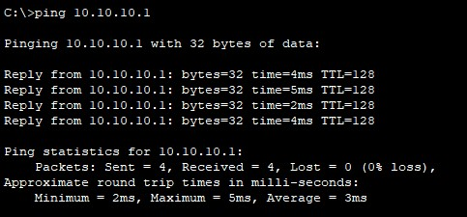

Checking connectivity of first pc and last pc.

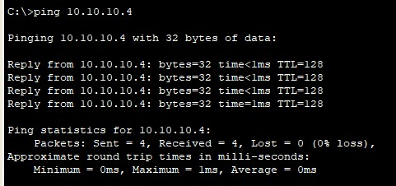

**Hence this is how we can use Cisco Packet Tracer to make Network topologies and stimulate that in real time.**